Code:

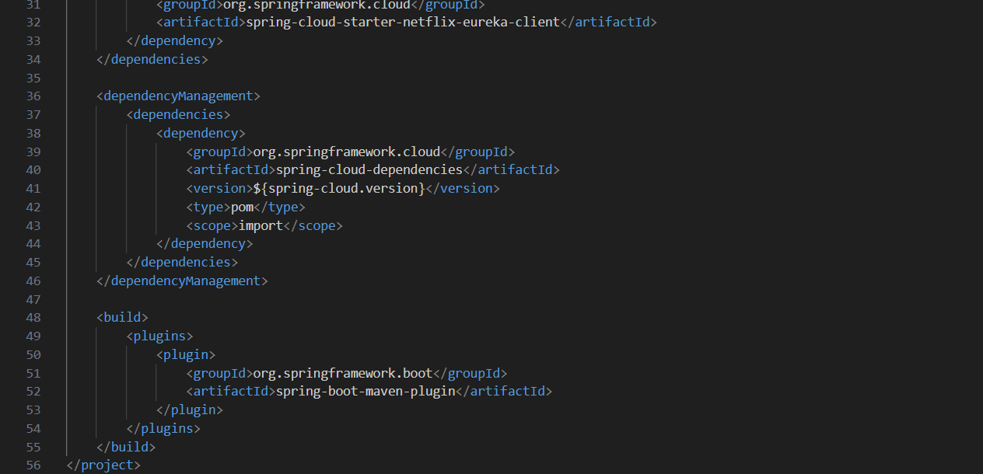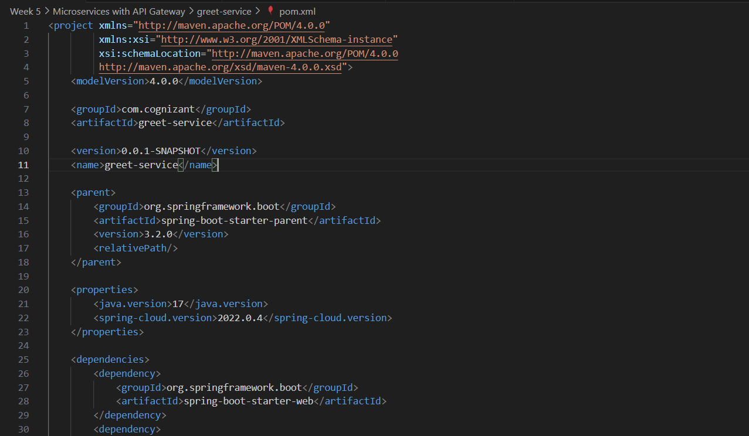pom.xml

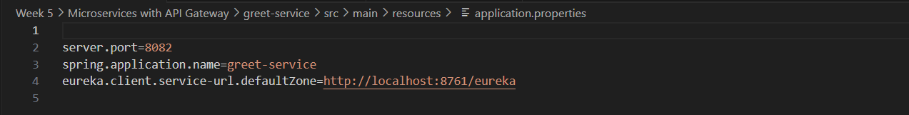application.properties

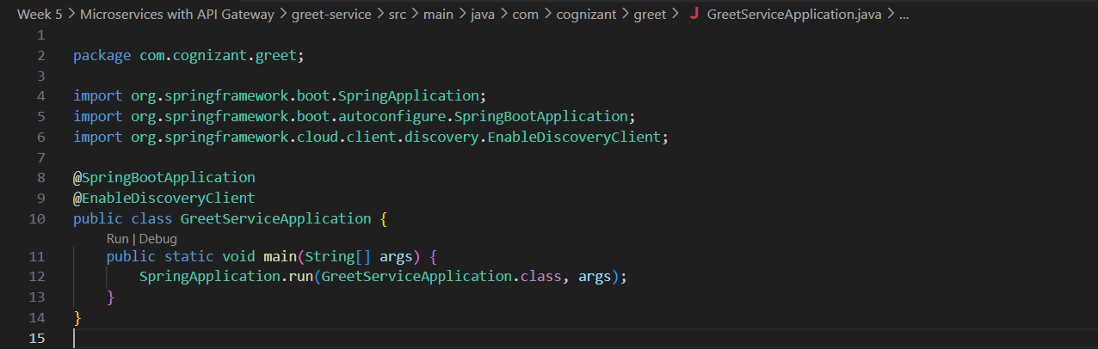GreetServiceApplication.java

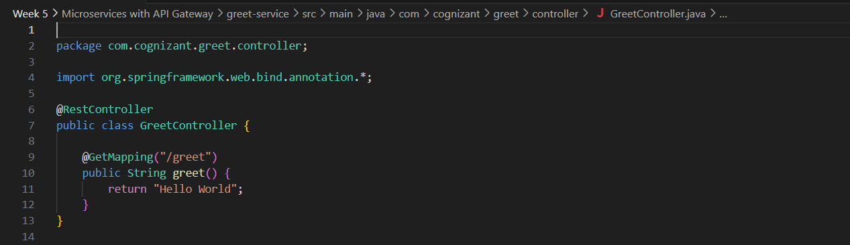GreetController.java